Prepositions of place

NAME:……………………………………………………………………………………….. CLASS:…………………….
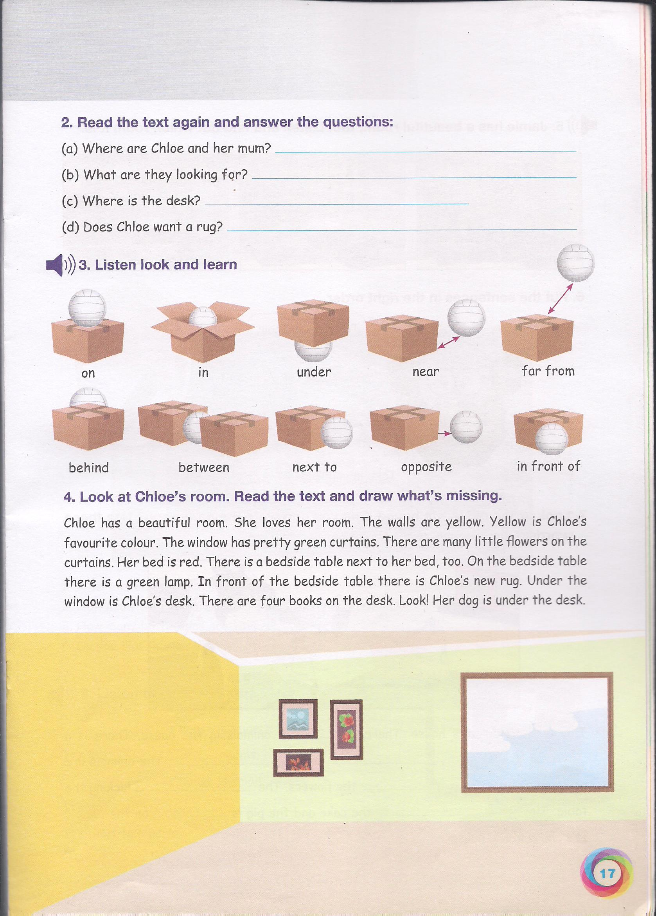
- Let’s remember!

Write T (TRUE ) OR F (FALSE)

1- THE CHAIR IS NEXT TO THE DESK.
2-THE DESK IS BETWEEN THE BEDS.
3-THE COMPUTER IS UNDER THE DESK
4-THE BOOKCASE IS ON THE WALL.
5-THE DOLL IS BETWEEN THE BED AND THE DESK.
6-THE LAMP IS ON THE DESK.
7-THE POSTERS ARE ON THE BED.
8-THE WINDOWS ARE ON THE FLOOR.
9-THE CLOCK IS ON THE BED.

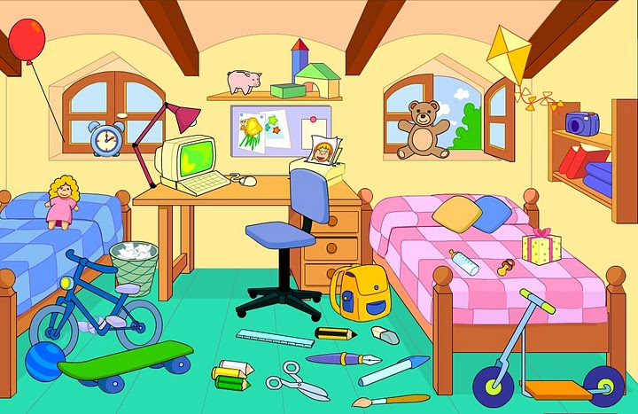

Where is the dog?

Match the prepositions of place to the correct pictures.
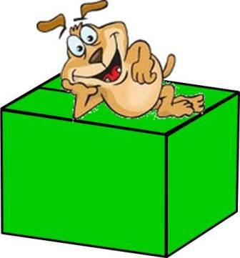
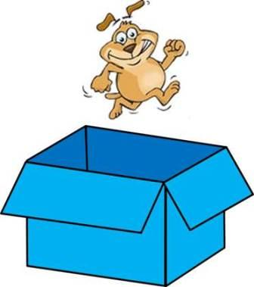


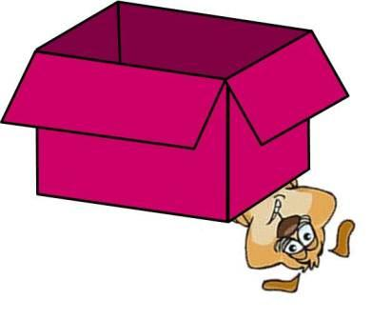
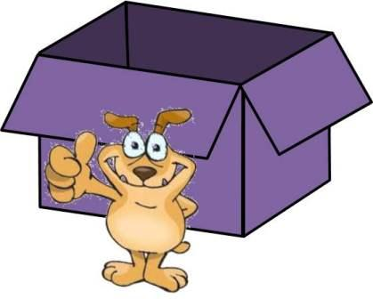
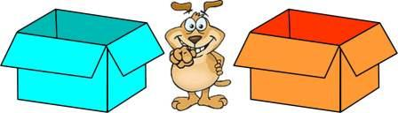
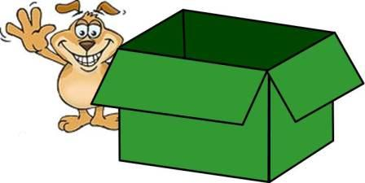









behind


between

in

in front of

next to

on

over

under

