PLACES IN A TOWN 2

Name:…………………………………………………………………………. Class:...................

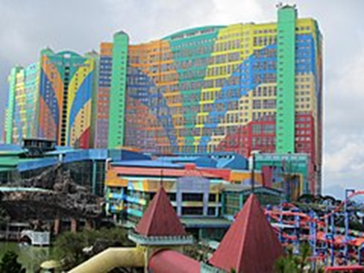
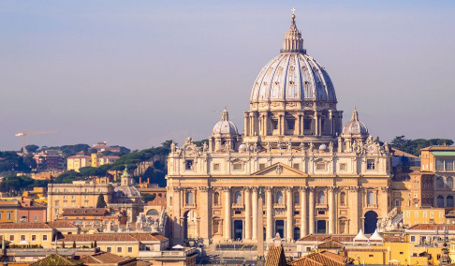
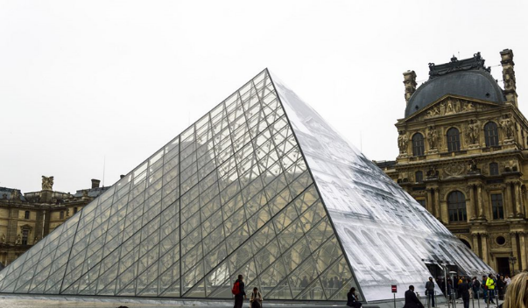
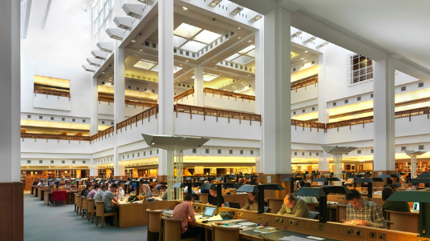
- Let’ s read:
d. The “First World Hotel” has the Guinness World Record for the biggest hotel in the world. It is a three star hotel in Malaysia. It has 36 floors with the total of 7,351 rooms.
c. St. Peter’s Basilica in Vatican City, in Rome, is said to be the biggest church in the world. The inside of the church was painted by famous artists like Michelangelo and Bernini. It is one of the most important places to visit in Rome.
b. The Louvre Art Museum is the largest art museum in the world with a gallery space of 72,735 square metres. It is in Paris. The Louvre is also the most visited museum in the world, receiving 7.4 million visitors every year. One of the most famous paintings that people can see there is “Mona Lisa” painted by Leonardo Da Vinci.
- The British Library is the National Library of the United Kingdom. It is the largest library in the world. It has about two million items (books, newspapers, maps etc) from all over the world.

- Circle the right answer

- The Louvre is the world's biggest:
transport museum
art museum
library

- The biggest hotel in the world is in:
Paris
London
Malaysia

- The biggest church in the world is:
The Louvre
St. Peter's Basilica
The British Library

- At the British Library you can:
read and borrow books
buy books
stay when you are on holiday

- At the Louvre you can see:
a famous painting from Leonardo Da Vinci
a famous painting from Picasso
almost 2 million books

- At the First World Hotel you can:
see interesting things
stay when you are on holiday
buy books

- Find the hidden words:
BOOKSTORE, AIRPORT, BANK, PARK, POLICE STATION, HOSPITAL, RESTAURANT, POST OFFICE, SHOPPING MALL

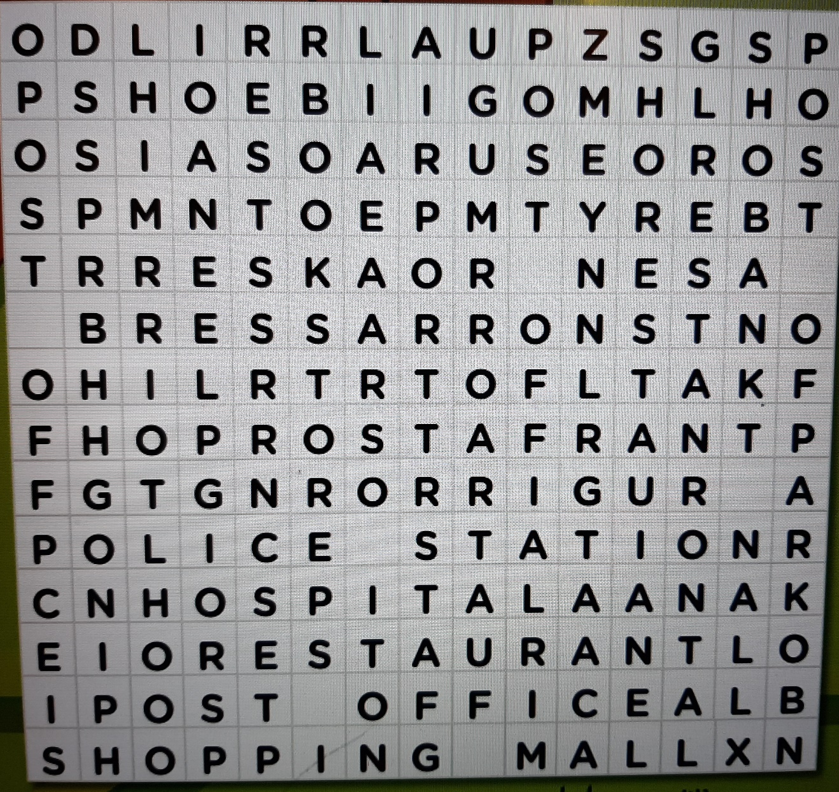

- Write the words in small letters

BOOKSTORE, AIRPORT, BANK, PARK, POLICE STATION, HOSPITAL, RESTAURANT, POST OFFICE, SHOPPING MALL

BOOKSTORE bookstore

AIRPORT

BANK

PARK

POLICE STATION

HOSPITAL

RESTAURANT

POST OFFICE

SHOPPING MALL
