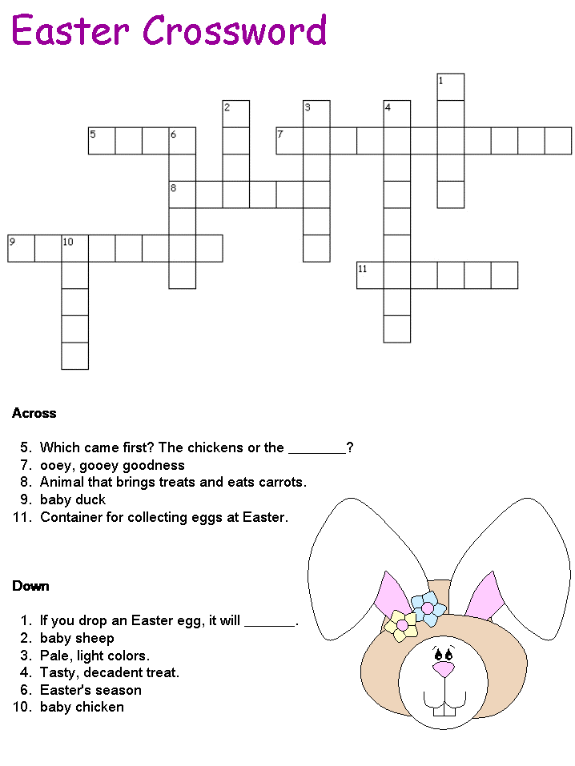
Eggs, spring, rabbit, lamb, marshmallow, duckling(=duck), chick (=chicken), chocolate, crack(=break), pastel, rabbit, basket.

