Name: …………………………………………………………………………………………………………………………………………….. Class:…………

- Look at the picture and complete the sentences with the prepositions of place:
in - on - under - next to - in front of - behind - between.
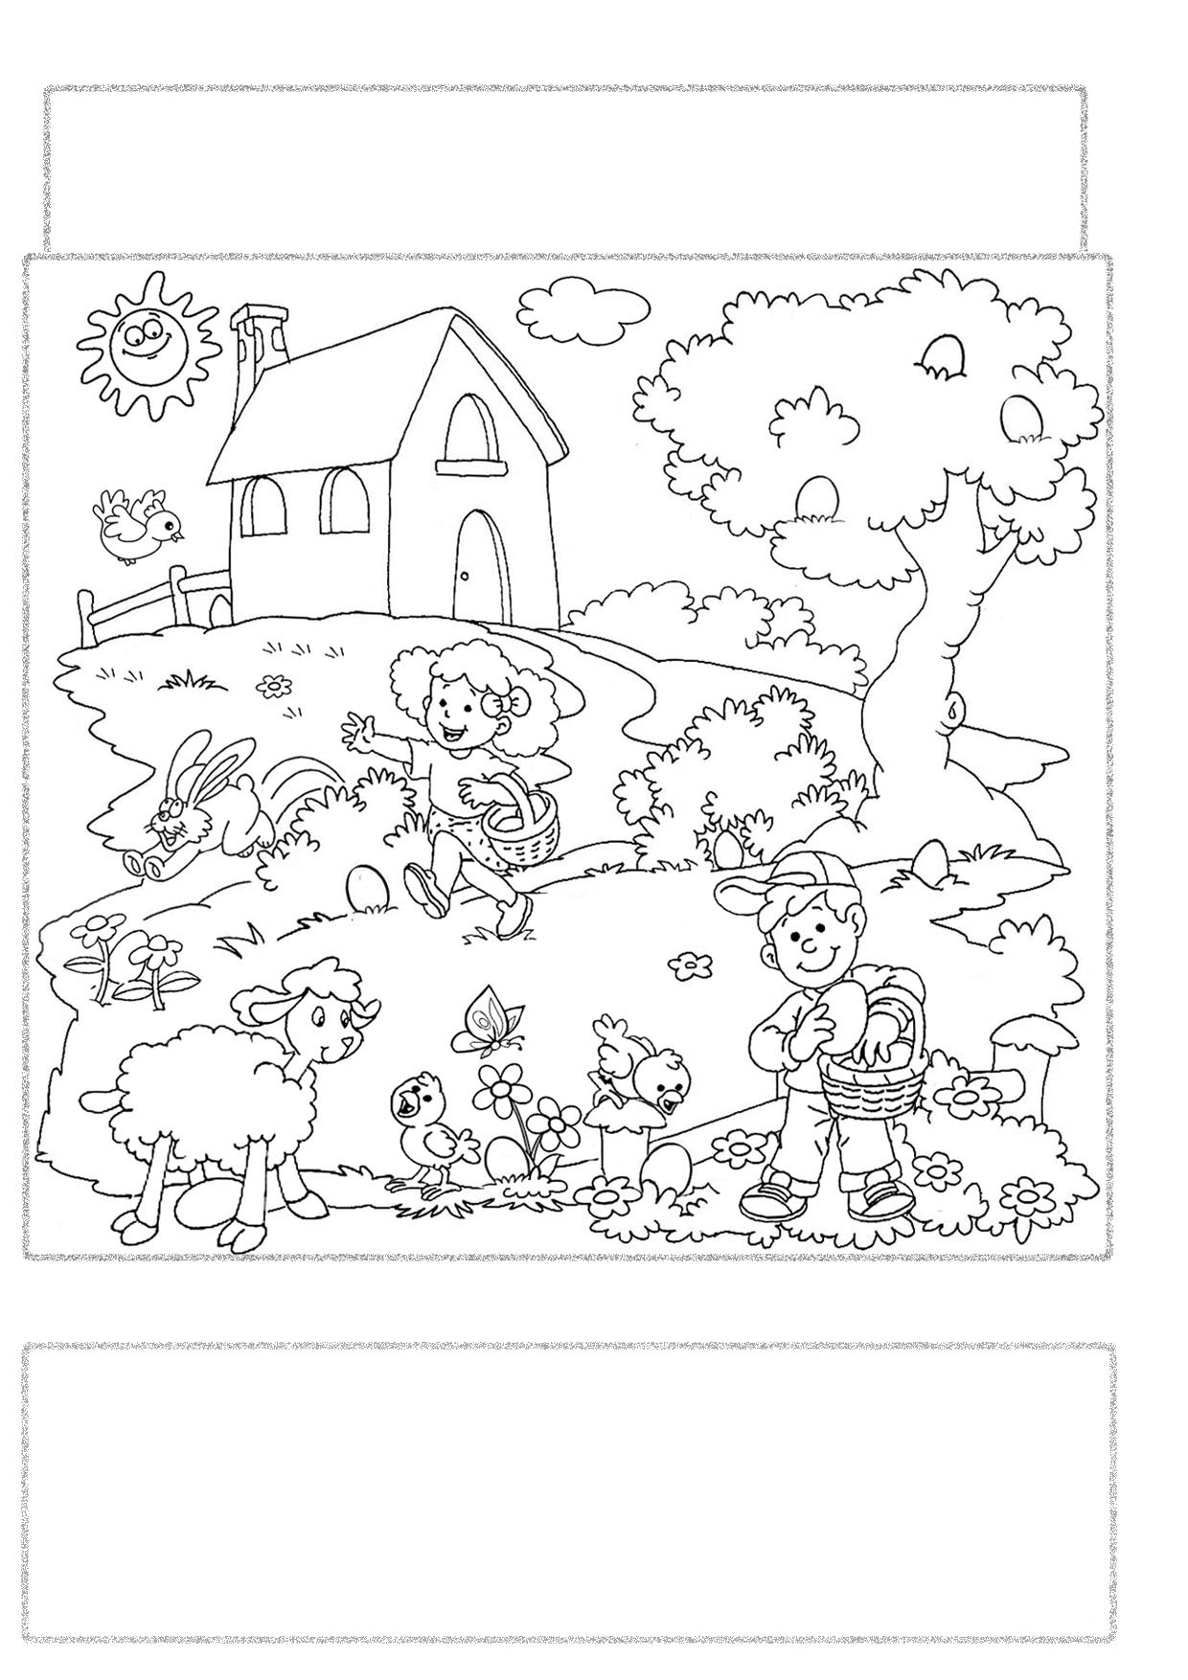

There is an egg ………………….………… the boy. It's brown.
There is an egg ……………….…………… the flowers. It's red.
There is an egg ………………….………… the tree. It's purple.
There is an egg …………………….……… the sheep. It's blue.
There is an egg ……………………….…… the ears of the rabbit. It's green.
There is an egg ……………………….…… the bush. It's orange.
There are three eggs …………………… the tree. They are yellow, blue and pink.

- Answer the questions.

- How many eggs can you find in the picture?
……………………………………………………………………………………..
- How many children are there?
……………………………………………………………………………………..
- How many eggs has got the boy?
……………………………………………………………………………………..
- How many flowers are there?
………………………………………………………………………………………
- Can you find a bird in the picture?
………………………………………………………………………………………
- Is there a butterfly in the picture?
………………………………………………………………………………………

